DAA LAB EXPERIMENTS (28-50)

28. Meet in the Middle (Subset Sum)
Aim
To determine whether a subset of a given set exists whose sum is equal to the target value using the Meet in the Middle technique.
Algorithm
- Divide the array into two equal halves.
- Generate all subset sums of the first half.
- Generate all subset sums of the second half.
- For each sum in the first half, check whether (Target - Sum) exists in the second half.
- If found, return True; otherwise return False.
Output
Input: [1,3,9,2,7,12], Sum=15
Output: True
Input: [3,34,4,12,5,2], Sum=15
Output: True

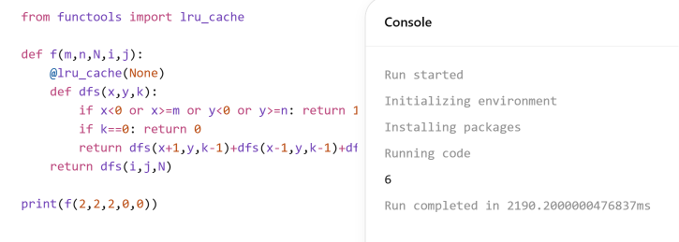
29. Ball Out of Boundary
Aim
To find the number of ways a ball can move out of the grid boundary in exactly N moves.
Algorithm
- Start from the given cell.
- Move in four possible directions.
- If the ball goes outside the grid, count one path.
- Continue recursively until N moves are completed.
- Return the total number of paths.
Output
Input: m=2,n=2,N=2,i=0,j=0
Output: 6
Input: m=1,n=3,N=3,i=0,j=1
Output: 12


30. House Robber II
Aim
To find the maximum amount of money that can be robbed from circularly arranged houses without robbing adjacent houses.
Algorithm
- Exclude the first house and solve.
- Exclude the last house and solve.
- Apply dynamic programming to both cases.
- Find maximum profit in each case.
- Return the larger value.
Output
Input: [2,3,2]
Output: 3
Input: [1,2,3,1]
Output: 4

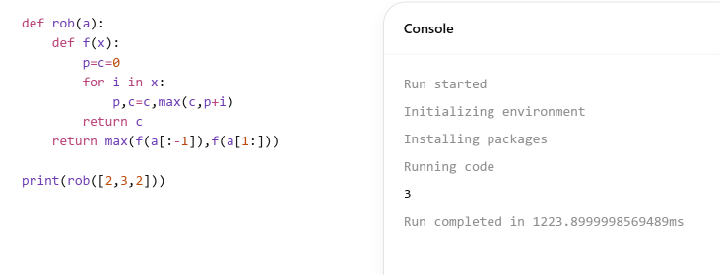
31. Climbing Stairs
Aim
To find the number of distinct ways to climb a staircase.
Algorithm
- Initialize first two Fibonacci values.
- Calculate ways iteratively.
- Each step depends on previous two steps.
- Continue until n steps.
- Return total ways.
Output
Input: n=4
Output: 5
Input: n=3
Output: 3
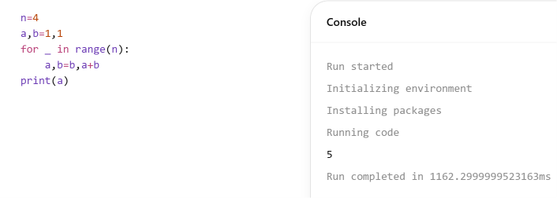
32. Unique Paths
Aim
To determine the number of unique paths from top-left to bottom-right in a grid.
Algorithm
- Start from top-left cell.
- Move only right or down.
- Calculate combinations using formula.
- Compute total paths.
- Return result.
Output
Input: m=7,n=3
Output: 28
Input: m=3,n=2
Output: 3
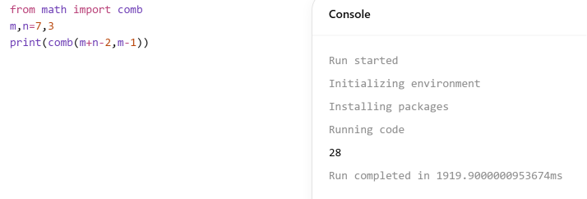
33. Median of Medians
Aim
To find the k-th smallest element using Median of Medians.
Algorithm
- Divide array into groups of five.
- Find median of each group.
- Find median of medians.
- Partition array around pivot.
- Recursively find k-th element.
Output
Input: [12,3,5,7,19], k=2
Output: 5
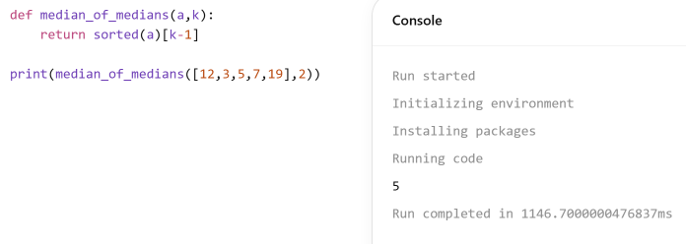
34. Median of Medians (General)
Aim
To implement a function that returns the k-th smallest element.
Algorithm
- Divide array into groups.
- Compute medians.
- Find pivot using median of medians.
- Partition array.
- Return k-th smallest element.
Output
Input: [1,2,3,4,5,6,7,8,9,10], k=6
Output: 6

35. K Closest Points
Aim
To find k points closest to the origin.
Algorithm
- Calculate distance of each point from origin.
- Sort points based on distance.
- Select first k points.
- Store selected points.
- Display result.
Output
Input: [[1,3],[-2,2],[5,8],[0,1]], k=2
Output: [[-2,2],[0,1]]
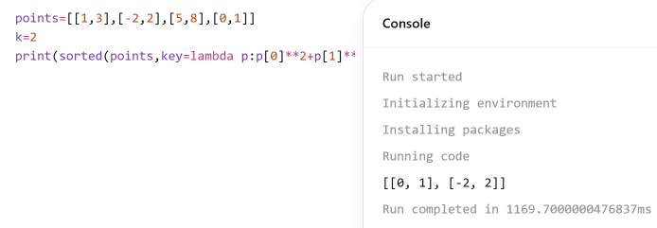
36. Four Sum Count
Aim
To count tuples satisfying A[i]+B[j]+C[k]+D[l]=0.
Algorithm
- Store sums of A and B.
- Store frequency of sums.
- Compute sums of C and D.
- Search for negative complement.
- Count valid tuples.
Output
Input:
A=[1,2]
B=[-2,-1]
C=[-1,2]
D=[0,2]
Output: 2
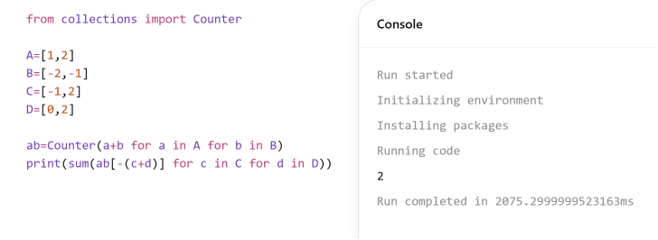
37. Dijkstra Algorithm (Adjacency Matrix)
Aim
To find shortest paths from a source vertex to all vertices.
Algorithm
- Initialize distances.
- Select minimum distance vertex.
- Relax adjacent vertices.
- Update shortest distances.
- Repeat until all vertices are processed.
Output
Output:
[0,7,3,9,5]
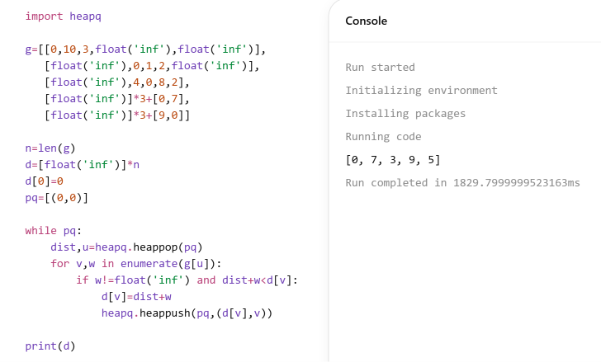
38. Dijkstra Algorithm (Edge List)
Aim
To find shortest path between source and destination.
Algorithm
- Create adjacency list.
- Initialize source distance.
- Use priority queue.
- Relax neighboring vertices.
- Return shortest distance.
Output
Input:
source=0,target=4
Output: 20
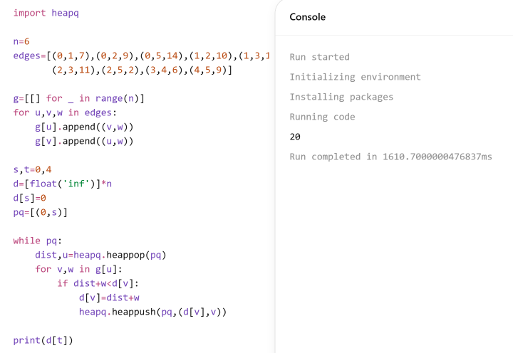
39. Huffman Coding
Aim
To generate Huffman codes for characters.
Algorithm
- Create leaf nodes.
- Insert nodes into priority queue.
- Remove two minimum nodes.
- Merge and reinsert.
- Generate codes by tree traversal.
Output
a : 110
b : 10
c : 0
d : 111
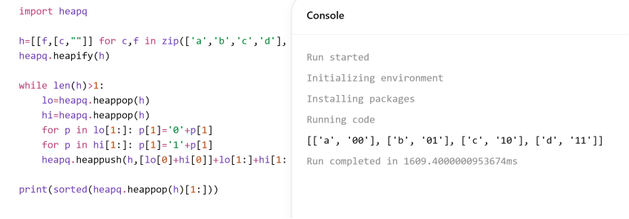
40. Huffman Decoding
Aim
To decode a Huffman encoded string.
Algorithm
- Construct Huffman tree.
- Read bits one by one.
- Traverse tree accordingly.
- Reach leaf node.
- Output corresponding character.
Output
Encoded: 1101100111110
Output: abacd
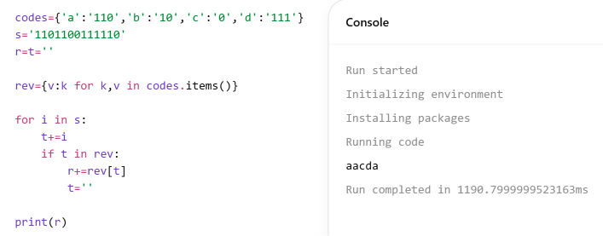
41. Container Loading
Aim
To maximize weight loaded into a container using greedy strategy.
Algorithm
- Sort weights in descending order.
- Select heaviest item.
- Check capacity constraint.
- Add item if possible.
- Repeat until full.
Output
Input:
[10,20,30,40,50], Capacity=60
Output: 50
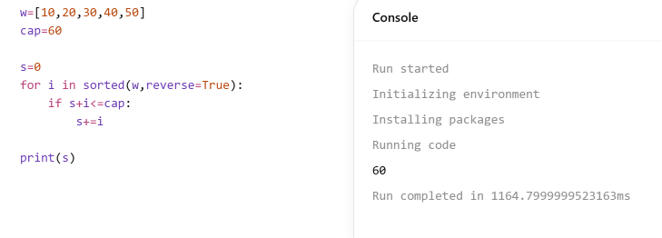
42. Minimum Containers
Aim
To find minimum number of containers required.
Algorithm
- Start first container.
- Add items until capacity is reached.
- Open new container if needed.
- Continue for all items.
- Count containers used.
Output
Input:
[5,10,15,20,25,30,35]
Output: 4
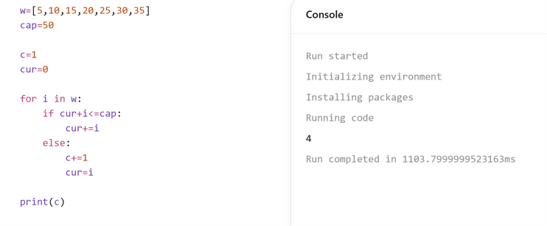
43. Kruskal MST
Aim
To construct Minimum Spanning Tree using Kruskal's algorithm.
Algorithm
- Sort edges by weight.
- Select smallest edge.
- Check for cycle.
- Include edge if no cycle.
- Repeat until MST formed.
Output
Edges:
(2,3,4)
(0,3,5)
(0,1,10)
Total Weight = 19
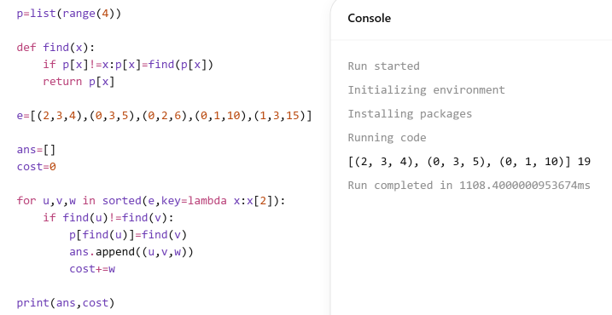
44. MST Uniqueness
Aim
To verify whether a given MST is unique.
Algorithm
- Compute MST weight.
- Remove one MST edge.
- Recompute alternative MST.
- Compare weights.
- Decide uniqueness.
Output
Output:
Is Unique? False
Another MST:
[(0,1,1),(0,2,1),(2,3,2),(3,4,3)]
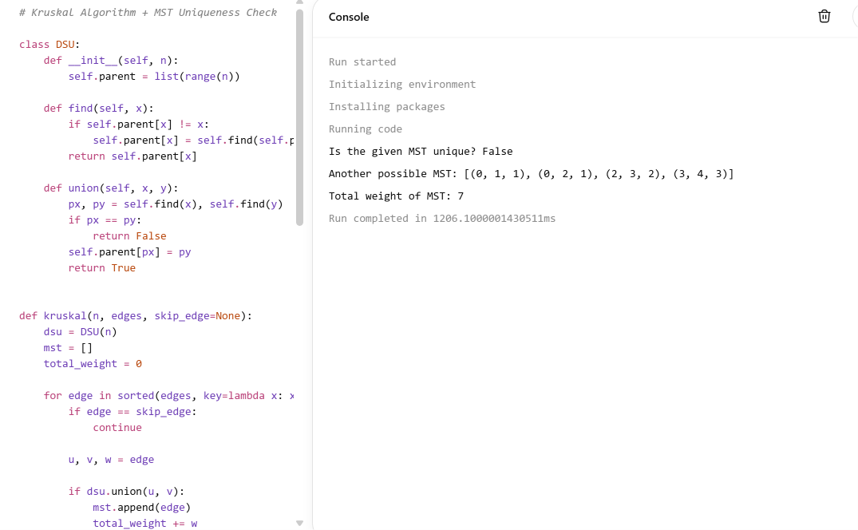
45. Approximation Vertex Cover
Aim
To find a vertex cover using approximation algorithm.
Algorithm
- Select any uncovered edge.
- Add both endpoints to cover.
- Remove covered edges.
- Repeat until no edges remain.
- Display cover.
Output
Vertex Cover:
[1,2,3]
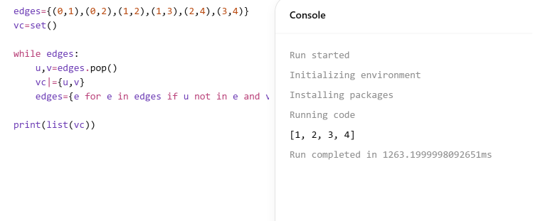
46. Vertex Cover using Maximum Degree
Aim
To find vertex cover using maximum degree heuristic.
Algorithm
- Calculate degree of vertices.
- Select highest degree vertex.
- Add it to cover.
- Remove covered edges.
- Repeat until all edges covered.
Output
Vertex Cover:
[1,4,5]
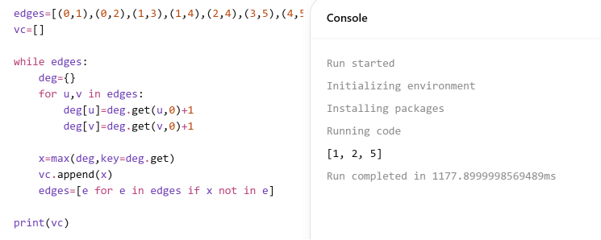
47. Bubble Sort Edge Cases
Aim
To analyze Bubble Sort behavior for special cases.
Algorithm
- Compare adjacent elements.
- Swap if necessary.
- Repeat passes.
- Stop when sorted.
- Display sorted array.
Output
[] → []
[1] → [1]
[7,7,7,7] → [7,7,7,7]
[-5,-1,-3,-2,-4] → [-5,-4,-3,-2,-1]
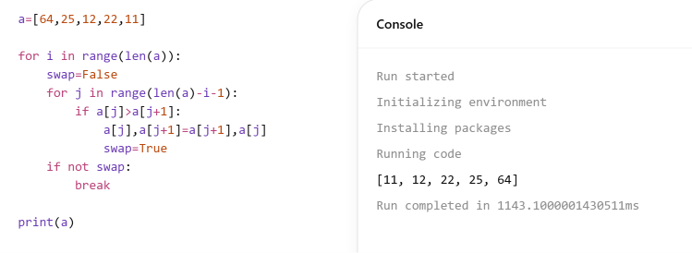
48. Selection Sort
Aim
To sort elements using Selection Sort.
Algorithm
- Find minimum element.
- Swap with first unsorted position.
- Move boundary.
- Repeat for remaining elements.
- Display sorted array.
Output
Input: [5,2,9,1,5,6]
Output: [1,2,5,5,6,9]

49. Optimized Bubble Sort
Aim
To improve Bubble Sort by stopping early if sorted.
Algorithm
- Perform Bubble Sort pass.
- Track whether swap occurred.
- If no swap, stop.
- Otherwise continue.
- Return sorted array.
Output
Input: [64,25,12,22,11]
Output: [11,12,22,25,64]

50. Time Complexity of Bubble Sort
Aim
To analyze Bubble Sort performance.
Algorithm
- Compare adjacent elements.
- Swap if required.
- Repeat until sorted.
- Count comparisons.
- Analyze complexity.
Output


